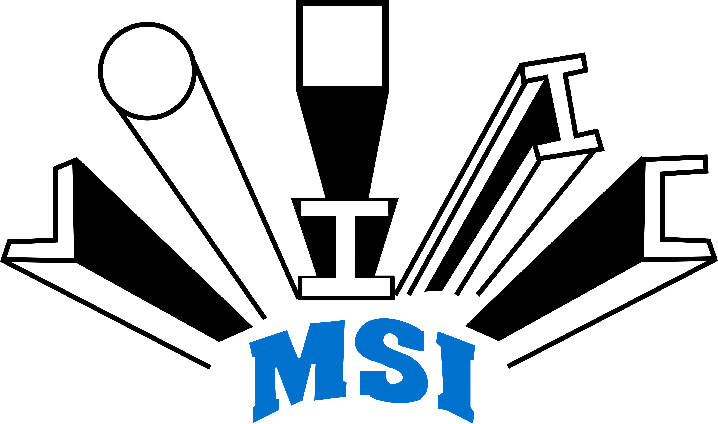
 STEEL INDUSTRIES LIMITED
Regd. Office: Plot No. B/8-9, Sector C, Sarora
Urla Industrial Complex, Raipur 493 221 (C.G.)
Ph.+91-771-4910058
E-mail: marketing@mahamayagroup.in Website: www.mahamayagroup.in
CIN: L27107CT1988PLC004607

CRITERIA OF MAKING PAYMENTS TO NON-EXECUTIVE DIRECTORS
As per Regulation 46 (2) (f) of the SEBI (Listing Obligations & Disclosure Requirements) Regulations, 2015 Listed entity shall disseminate following information on the website of the Company:

Criteria of making payments to non-executive directors (NEDs)

In keeping with the above, any fee/remuneration payable to the NEDs of the Company shall abide by the following:

Sitting Fee: Independent Directors ("ID") and Non-Independent Non-Executive Directors ("NEDs") may be paid sitting fees (for attending the meetings of the Board and of committees of which they may be members) as required by Companies Act, 2013, Listing Agreement or other applicable law or for any other purpose whatsoever as may be decided by the Board. Quantum of sitting fees may be subject to review on a periodic basis, as required.

Commission: Under the Companies Act, 2013, Section 197 allows a company to pay remuneration to its “IDs” and “NEDs” either by way of a monthly payment or at a specified percentage of the net profits of the company or partly by one way and partly by the other. Further, the section also states that where the company has either managing director or whole-time director or manager, then a maximum of 1% of its net profits can be paid as remuneration to its NEDs. In case there is no managing director or whole-time director or manager, then a maximum of 3% of net profit can be paid. Thus, the basis of payment to the NEDs is the net profit of the Company.

The Company is however not obligated to remunerate its NEDs.

Within the parameters prescribed by law, the payment of sitting fees and commission will be recommended by the NRC and approved by the Board.

Currently the Company is not paying Commission to its “IDs” and “NEDs”.

Professional Fees: Under the Companies Act, 2013, Section 197 allows a Company to pay remuneration to its “IDs” and “NEDs” for services rendered by any such Director if:

a) The services rendered are of Professional nature;
b) In the opinion of Nomination and Remuneration Committee the Director possess the requisite qualification for the practice of the profession.

As per the provision of Section 188 of the Companies Act, 2013, the Audit Committee and the Board of Directors of the Company shall approve the Professional fees to be paid to Non-Executive Director(s), and with the approval of the Shareholders where ever required.

Reimbursement of actual expenses incurred: the Company may pay to any Director such fair and reasonable expenditure, as may have been incurred by the Director while performing his/her role as a Director of the Company.
This could include reasonable expenditure incurred by the Director for attending Board/Board committee meetings, general meetings, court convened meetings, meetings with shareholders/creditors/ management, site visits, induction and training (organized by the Company for Directors) and in obtaining professional advice from independent advisors in the furtherance of his/her duties as a director.

************

