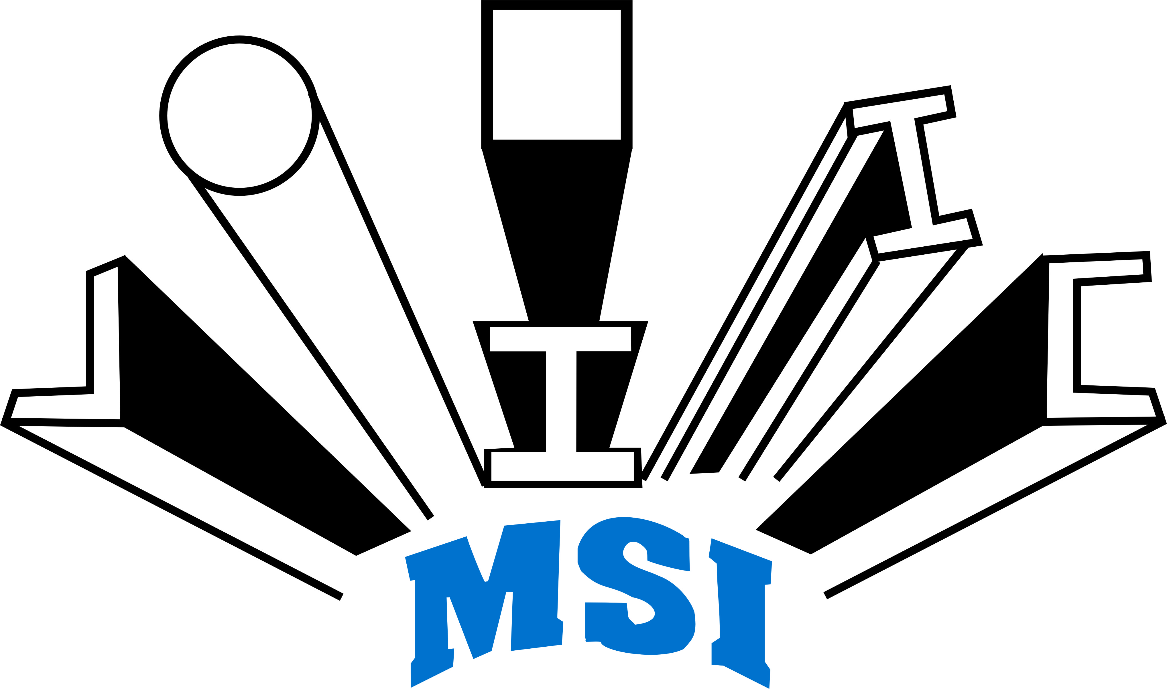
STEEL INDUSTRIES LIMITED
Regd. Office: Plot No. B/8-9, Sector C, Sarora
Urla Industrial Complex, Raipur 493 221 (C.G.)
Ph.+91-771-4910058
E-mail: marketing@mahamayagroup.in Website: www.mahamayagroup.in
CIN: L27107CT1988PLC004607

Familiarization Programme for Independent Directors

Pursuant to Regulation 25(7) of Securities and Exchange Board of India (Listing Obligations and Disclosure Requirements) Regulations, 2015, the Company has organized a Familiarization Programme to all the Independent Directors on 1st March, 2023. All the Independent Directors along with the Executive Directors has visited our plant situated at B/8-9, Sector C, Sarora Urla Industrial Complex, Raipur 493 221 (C.G.) to familiarize them with the various operations and Products of the Company.

Details as per Regulation 25(7) and Regulation 46(2)(i) of Securities and Exchange Board of India (Listing Obligations and disclosure Requirements) Regulations, 2015:

Financial Year | Number of Programmes attended by Independent Directors |  | Number of hours spent by Independent Directors
 | During the Year | Cumulative till date | During the Year | Cumulative till date
2015-16 | 1 | 1 | 3 | 3
2016-17 | 1 | 2 | 2 | 5
2017-18 | 1 | 3 | 2 | 7
2018-19 | 1 | 4 | 2 | 9
2019-20 | 1 | 5 | 3 | 12
2020-21 | 1 | 6 | 2 | 14
2021-22 | 1 | 7 | 2 | 16
2022-23 | 1 | 8 | 3 | 19

